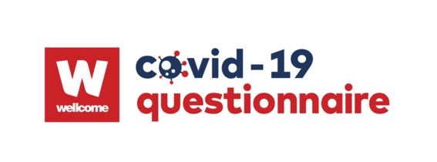

Wellcome Trust LPS Questionnaire Resource

Updated: June 2021
Notes
- To reference data collected using this resource describe with:
Data gathered from questionnaire(s) provided by Wellcome Longitudinal Population Study Covid-19 Steering Group and Secretariat (221574/Z/20/Z)

- To contact the secretariat for updates, support and advice email
wellcomecovid-19@bristol.ac.uk

- If using logos, please use the Wellcome Covid-19 logo on your questionnaire for participants alongside your own institution.

- Please tag @covid19qs on twitter and/or link to http://www.bristol.ac.uk/alspac/researchers/wellcome-covid-19/ where appropriate.

a. Formatting & Details
All questions that were not from ALSPAC questionnaire 1 and 2 have been given a source tag.
Red text indicates where the question’s original wording has been amended.
[[Italic text in double squares bracket is note about question, not to be shown to participant.]]

COVID-19 Knowledge and Policy

COVID-19 Knowledge
- How would you rate your knowledge about COVID-19?
  - Extremely good
  - Somewhat good
  - Neither good nor bad
  - Somewhat bad
  - Extremely bad

- I get information about Covid-19 (the coronavirus) from: (choose all that apply)
 | The origin of the virus | The spread of the virus in the UK and other countries | The rules which apply during lockdown | The best way to stay healthy during lockdown | How to get better if you catch the virus | How to prevent others from getting infected by the virus
Friends, family, colleagues
Workplace
Television
Printed media
Printed health education posters
Social media
Official websites including the UK Government, NHS, WHO and CDC
Other websites
My doctor or other healthcare workers
Articles in scientific journals

- I think the following sources are: (choose one)
 | Very reliable | Slightly reliable | Neither reliable nor unreliable | Slightly unreliable | Very unreliable
Friends, family, colleagues
Workplace
Television
Printed media
Printed health education posters
Social media
Official websites including the UK Government, NHS, WHO and CDC
Other websites
My doctor or other healthcare workers
Articles in scientific journals

2. Communication of COVID-19 Information
- Do you find the UK Government guidance on COVID-19 easy to understand? [SOURCE: CovidLife3]
  - Extremely easy
  - Somewhat easy
  - Neither easy nor difficult
  - Somewhat difficult
  - Extremely difficult

- Do you find the Scottish Government guidance on COVID-19 easy to understand? [SOURCE: CovidLife3]
  - Extremely easy
  - Somewhat easy
  - Neither easy nor difficult
  - Somewhat difficult
  - Extremely difficult
- On a scale of 1 (not at all difficult) to 10 (extremely difficult), how difficult has it been for you to find accurate, understandable information about COVID-19? [Source: CovidLife3]
  - 1 … 10

- During the [the first lockdown / the second lockdown] from [23rd March 2020/5th January 2021], how easy or difficult do you think it [was/is] to follow the lockdown measures where you live? [Source: ONS]
  - Very easy
  - Easy
  - Neither easy nor difficult
  - Difficult (Show Q5)
  - Very difficult (Show Q5)

- For what reasons do you think it is difficult to follow lockdown measures? [Source: ONS]
  - Impact on income and household finances
  - Impact on health
  - Impact on wellbeing
  - Strain on relationships with family and friends
  - Life events being missed
  - Don’t feel coronavirus (COVID-19) is a personal risk
  - Coronavirus (COVID-19) is low in my rea
  - Other
  - Don’t know

